Minutes of the 2018
Annual General Meeting
Our Next Steps
(Easy Read Summary Version)
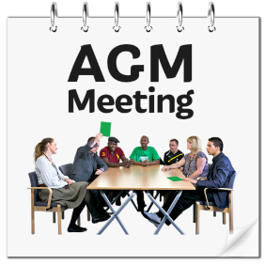 | East Kent Mencap’s 58th Annual General Meeting (AGM) took place on 18th October 2018 at New Gateway House.  The meeting started at 7:00pm.
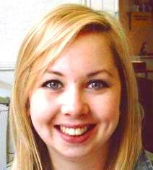 | The Chair, Amy Rutland welcomed everybody to the meeting and thanked them for coming.
 | She asked everybody to sign in.
SORRY  Sorry! | 35 people came to this meeting.  12 people gave apologies for not being there.
The minutes of the 2017 AGM were approved by the members.
Proposed by Doreen Leach
Seconded by Lynda Holding

Chair’s Report – Amy Rutland

The Chairperson makes sure that the Executive Committee meetings run smoothly.

Amy spoke about the expansion of services and investment in our housing stock.
She said goodbye to 3 trustees and welcomed Scott Cheater to the Executive Committee.
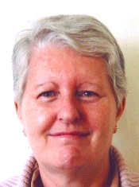 | Angela Stuart (Secretary) gave her report.  The Secretary makes sure that the Charity explains everything well.
Secretary’s Report – Angela Stuart
- Regular Meetings – To make decisions on how the Executive Committee can support members.
- Dances – Continue to be popular events.
- Fun Day – A very enjoyable but wet day at Margate Football Club.
- Expansion of services in East Kent.
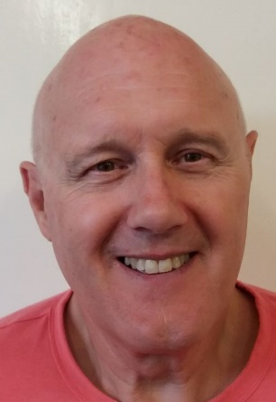 | Keith Smith (Acting Treasurer) gave his report.  The Treasurer is a person who makes sure that the charities funds are used properly.  Keith had been the Treasurer for 5 years until October 2017. He has been the Acting Treasurer since August 2018 when Claire Goldfinch retired.
Acting Treasurer’s Report – Keith Smith
Keith reported on:
- Funding
- Financial highlights
- Income and how we spend our money
Keith reported that our property value was up
compared to last year by £512,000

This is because we purchased the property in
Clarence Avenue.
The money that people owe East Kent Mencap
has doubled from £206,000 to £422,000.

Collecting this money is important and we have
employed a new staff member to help with this.
Money in the bank has gone down during the
year.

This is because we have purchased property and
more people owe us money.
We spent a lot of money improving our
properties.

We spend money to make properties safe and
nice places for our tenants and members.
 | Donations are down by 50%
Our costs had increased.
We employ more staff as our services have grown.

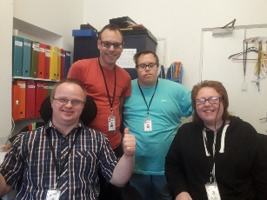 | The members’ committee visit services, ask questions and report their findings back to the CEO and the trustees.
Jason Gerlack the Chief Executive Officer (CEO) gave his report.

A CEO makes sure that the Charity is well led.

He focussed on the positives from the last year and the future.
He thanked all the people involved in making East Kent Mencap what it is.
CEO’s Report – Jason Gerlack
- We won a bid to purchase Foresters Hall.
- We were invited by KCC to run a service in Deal.
- We secured a contract to provide day services for 4 years.
- We appointed a new Operations Manager.
- We will continue to expand, modernise and replace our housing stock.
- We will continue to develop and improve services and partnerships.
- We will not tender for new Supporting Independence Service contracts.
- We will update our strategic plan to support a wider range of people.
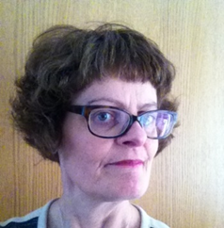 | Jane Brooke (Fundraising Manager) gave her report.  A fundraiser raises money for the charity.  Jane said goodbye to Dora Smith who had volunteered for the department for a long time.
Fundraising Report – Jane Brooke
- Grants and Events raised £205,615
- Donations and Gifts in Kind rasied £3838.46
- We communicate to raise awareness of the work we do.
- We use newsletters, social media and the press to do this.
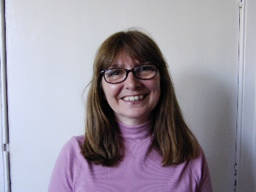 | Registered Operations Manager – Sue Beaumont  Sue Beaumont is the new Registered Operations Manager.  She introduced herself to the members at the AGM talking about her work history and what she thinks of East Kent Mencap so far.
Any Other Business

There was no other business.
Presentation of Officers and Committee
Members were asked to agree who they would like to run East Kent Mencap for the next year.
Amy Rutland was re-appointed as Chair.
Audrey Emmett was re-appointed as Vice Chair.
Keith Smith will be the Acting Treasurer until a replacement can be found.
Angela Stuart was re-appointed as Secretary.

The remainder of the Executive Committee voted in
are:
Scott Cheater, Doreen Leach, Lynda Holding, Paul Pinder, Mandy Rackley and Keith Smith.

Appointment of Auditors
Auditors check that our Charity is run well
The members decided to keep the services of the auditors, Percy Gore, for the coming year.
Proposed by Karen Loughrill
Seconded by Maria Kourellias
The meeting ended at 8:24pm

The next A.G.M. will take place in October 2019.
The date will be confirmed later.
The 50 Club does not run anymore.

Amy invited members to join the Thanet Community Lotto instead if they still wanted to help with fundraising.
This is summary of the 2018 AGM Minutes.

A full set of the minutes and copies of all the reports are available on request.

Please contact Lynda.Salisbury@eastkentmencap.co.uk
or call 01843-224482 if you would like a copy.

